Team Hybrid/HYDRA

Last Updated 9/8/2016

General

* Team Members
  + Jihane Bettahi - ECE
  + Tamra Nebabu - ECE/Physics
  + Henry Quach - ME
  + Raiyan Sobhan - BME
  + Garrett Andersen
* Meeting Schedule
  + Meet to discuss work and plans - Tuesdays from 10:05 to 11:20 @ Hudson
  + Meet to work on hardware - Fridays from 3:00 - 6:00 @ Foundry 113

Questions

* What rpm do we need to get the motor to, to properly generate “sufficient voltage”?
* Talk to quadcopter team or Brooke about whether our system charges a battery, or directory gives power to the rotor
* Questions for Zach:
  + Progress on programming the ESC: do we have everything we need?
  + Type of gasoline engine takes

Current Tasks / To Do

* Get hardware to work as it did at the end of the Fall 2015 Ocean Engineering Class
  + Follow procedure outlined by Zach and Pranava
    - Need to troubleshoot this because no schematic was provided
    - **Servo test utility is not functioning as it should**
* ~~Contact Zachary Podbela for information~~
  + Contacted as of 9/6/2015 at [Zachary.podbela@duke.edu](mailto:Zachary.podbela@duke.edu)
  + Zachary is currently working in NYC, but we can call him
  + Reschedule Meeting on Fridays
* Officialize team meeting schedule and come up with **key milestones and deliverables**

**Outrunner Motors**

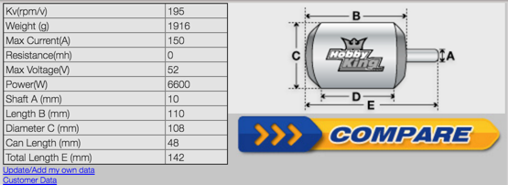

* <http://www.rcgroups.com/forums/showthread.php?t=1661188>
* <http://www.rcgroups.com/forums/showthread.php?t=1661182>
* Card Programming: http://www.hobbyking.com/hobbyking/store/uploads/174849581X53499X52.pdf
* General
  + Similar to car alternator
  + When the shaft of the outrunner is turned, 3 phase AC power is generated
  + “This has been demonstrated catastrophically on one occasion I'm aware of”
  + “Req ~10,000 rpm for a decent voltage”
  + “You could use a 3 phase FET bridge instead of a diode rectifier, but that becomes much more complicated”
  + “You will need an appropriately rated 3 phase rectifier, and a switch to disconnect the generator load when acting as a motor. The switch could be controlled by a servo connected to the throttle channel. For best efficiency the rectifier should use Schottky diodes”
  + “The simplest way to set it up is connect the rectifier directly to the motor, in parallel with the ESC. The output of the rectifier then goes through a switch (turned on only at zero throttle to avoid upsetting the ESC) to the load”.
  + Apparently Schottky diodes are best for efficiency
  + 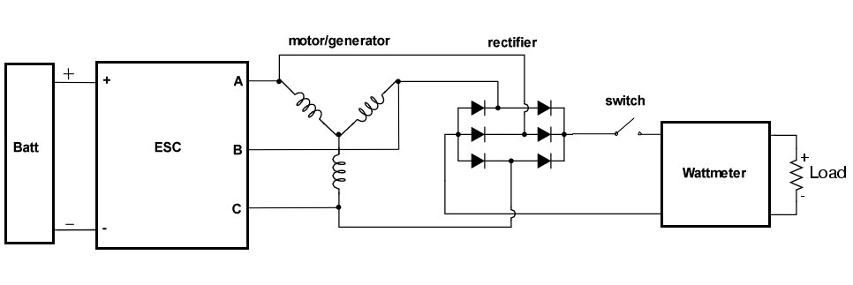
  + Terms to look up: Schottky diode